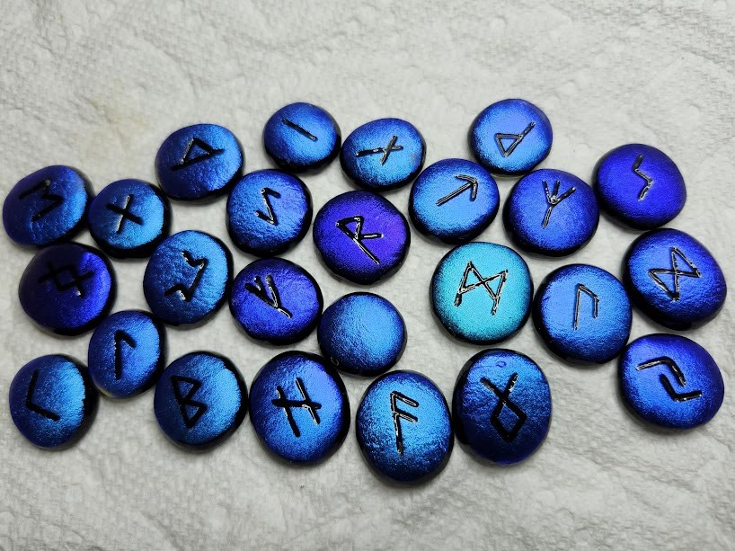

RUNE MEANINGS
The very first things I want to make you aware of is that the runes are generally a positive, guiding tool. It’s often used daily as something we can use just to help us look at what we might need to be mindful of for that day. Or to help clear up a problem we may be missing an answer for. They are very good for asking for help. But they are also for us, who are the readers, they can be our tool to help to advise and guide more fully than we could on our own. And you can make them out of anything if you don’t want to buy a set. You can use stone, wood, crystals, shoes, hats, small pets, anything you want that means something to you.
The three best known runic alphabets are: the Older Futhark , the Anglo Saxon Futhorc and the Younger Futhark. The motto of the runes could be the same words that were carved above the gate of the Oracle of Delphi KNOW THYSELF, as each of us is an Oracle in ourselves. Consulting the runes, another Oracle, puts you in touch with your own inner guidance, with that part of you that knows everything you need to know for your life now. So when you consult an Oracle you're not given directions as to what to do next, but what direction to look in, or points you to the direction of your hidden fears, or motivations that will help shape your future. As with most oracles of divination - Runes mean different things if held 'straight up' and mean the opposite if held in the 'reverse'.

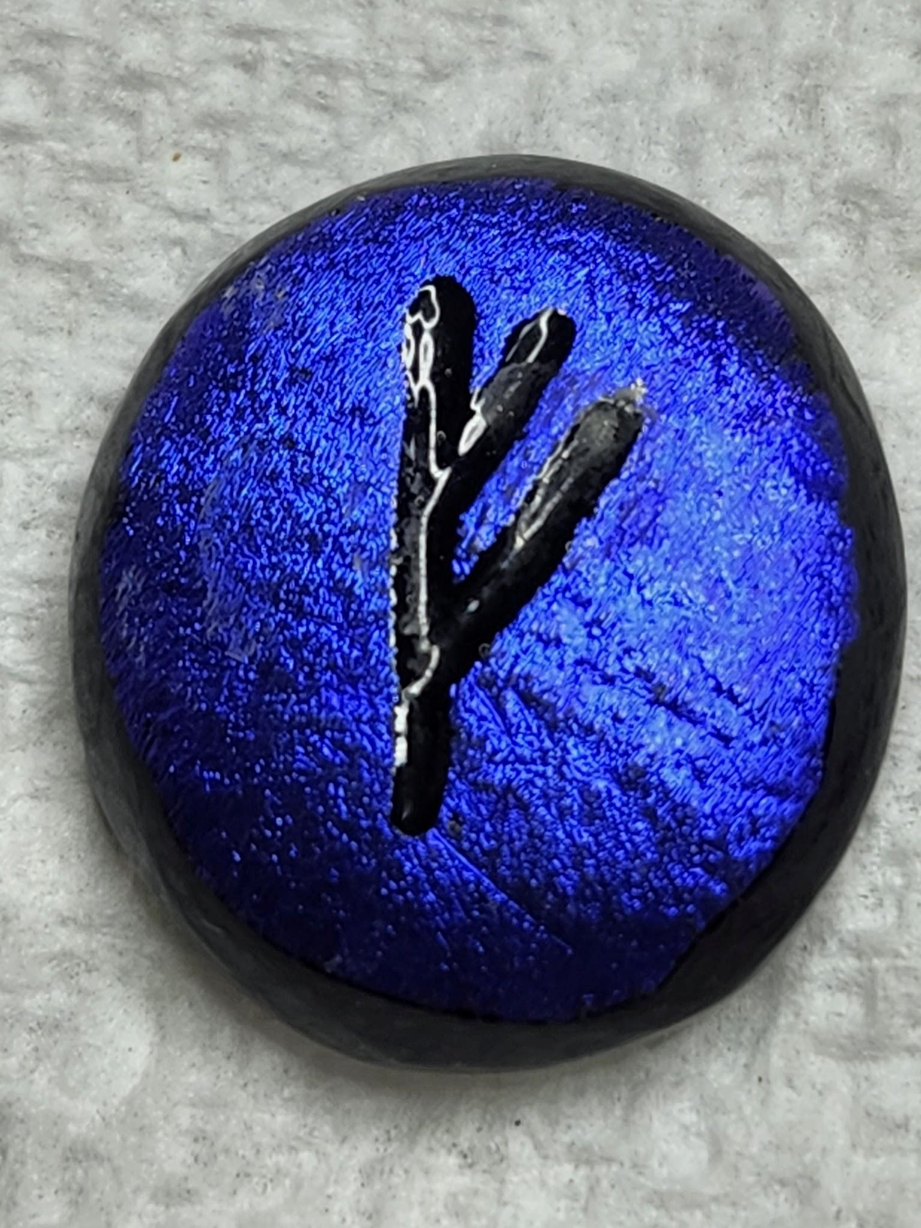 FEHU - Cattle/Nourishment/Possessions - It calls for you to probe deeply into yourself and determine whether it's possessions and wealth that are what you need or self-knowledge and growth within yourself. It's like the material wealth vs. spiritual wealth, where sometimes we may feel that what we have is more important than what we are, and we get blinded by possessions and lose ourselves in obtaining them. It can also mean material wealth, which is not a bad thing, may be what we should strive for right now, however don’t get reckless with it and share and appreciate it. If you look at the symbol you may be able to see someone standing tall, holding up their arms as if to say "Look what I have"! It's a positive feeling of achievement. REVERSED - Not a happy, positive time. You're seeing/feeling the bad side of success, maybe you hurt someone to achieve what you have, or gone against your principles or beliefs. You are going through trials and frustration where you keep getting close but just missing the mark and from this you're made aware of how to look at these blocks as a way to learn about yourself and/or the situation.
k

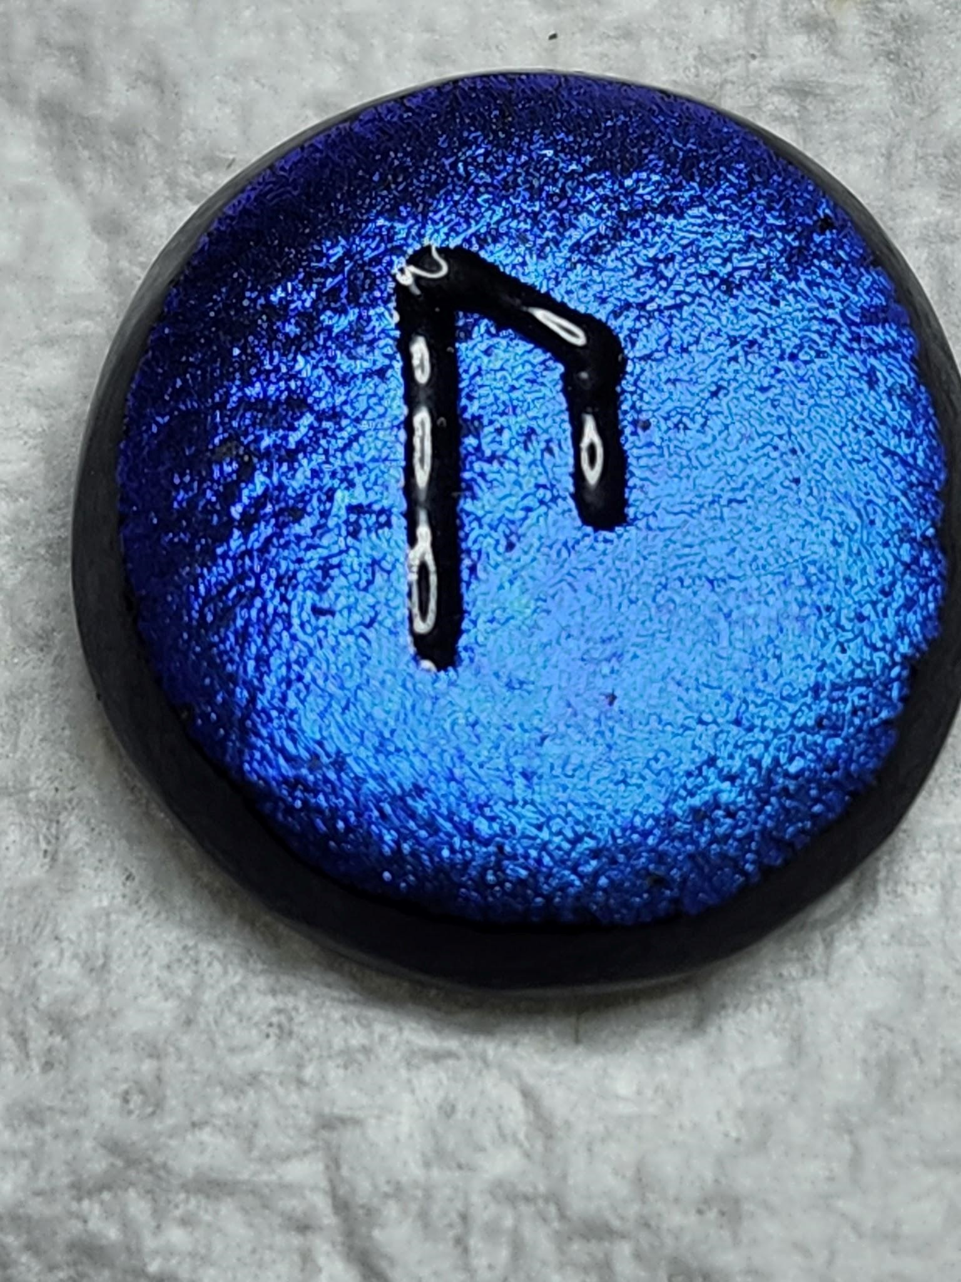 URUZ - strength/Man-Womanhood/Wild Ox - This is a rune of passage, part of a cycle, where you seem to hit bottom before you can go up, self-change, you have a choice with this - you can accept that you've hit bottom knowing you're to start building up new and fresh or you can resist the change, as we all have free will. Usually you'll find this an opportunity disguised as a loss. It seems like everything is a mess, but you realize it's just that you have to finish to begin again, and that your strength is the key, knowing you have it first of all, and learning how to use it and not be afraid of change. We are all much stronger than we realize. For those that don't realize it, we need to have ‘that moment’ or 'leap of faith' where we find out we have to get tough and get going, and have faith in our own self. Reversed –You’re missing the picture. You're not seeing or hearing or listening to what's right in front of you and you're seeing only the obstacles and feeling a lot of "poor me". You miss the important opportunities because you can't see the forest for the trees. Don't look at the obstacles/trees and open up and see the whole picture. If you look at this symbol it seems to be standing on it's own two legs, Strength, and reversed, like a turtle stuck on it's back unable to move.
g

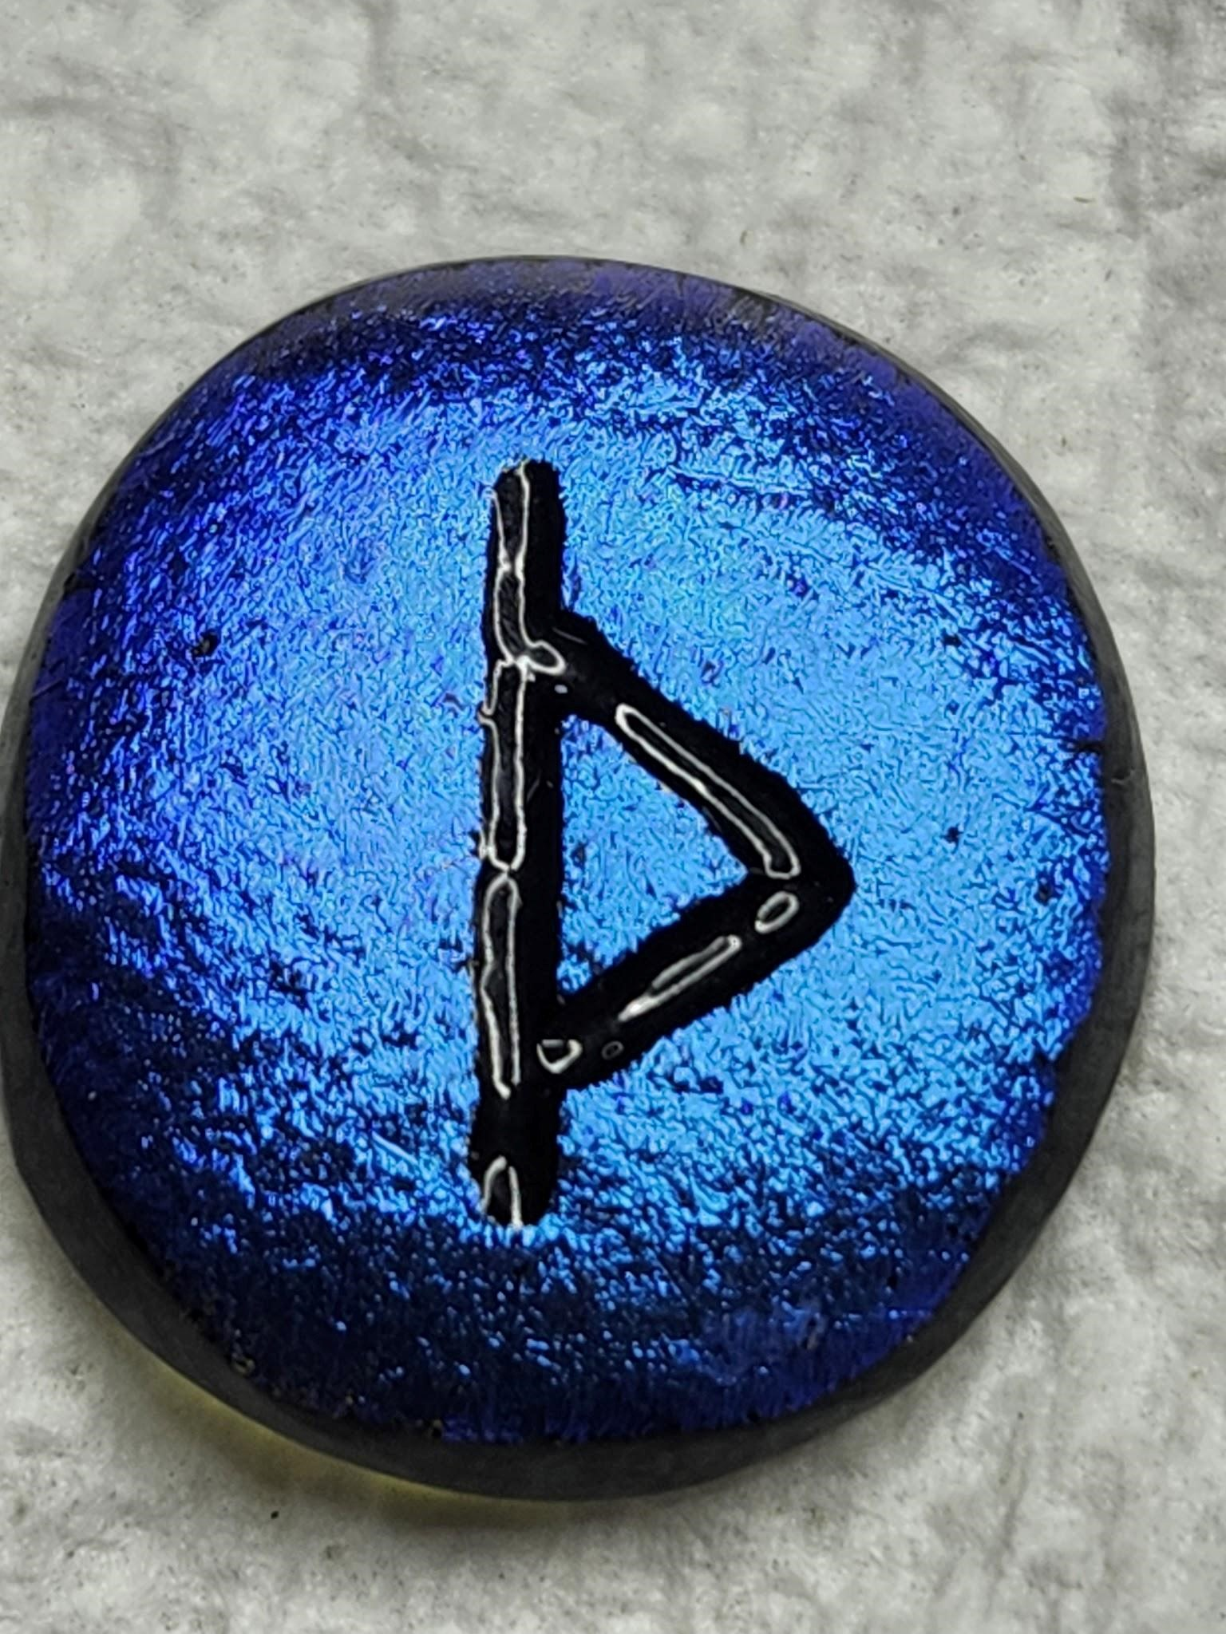- THURISAZ Gateway/Place of Non-Action - If you look at the symbol itself, think of it as a door with a handle, but the door is closed. This is a rune that wants you to contemplate before you move ahead, which is the "nonaction" part. You need to reflect, look inside yourself, get rid of what you don't need, get comfy with yourself, Before you take that step through the door. REVERSED - This is more of a warning, don't make hasty decisions, don't push yourself farther than you feel comfortable with, don't run blindly ahead.
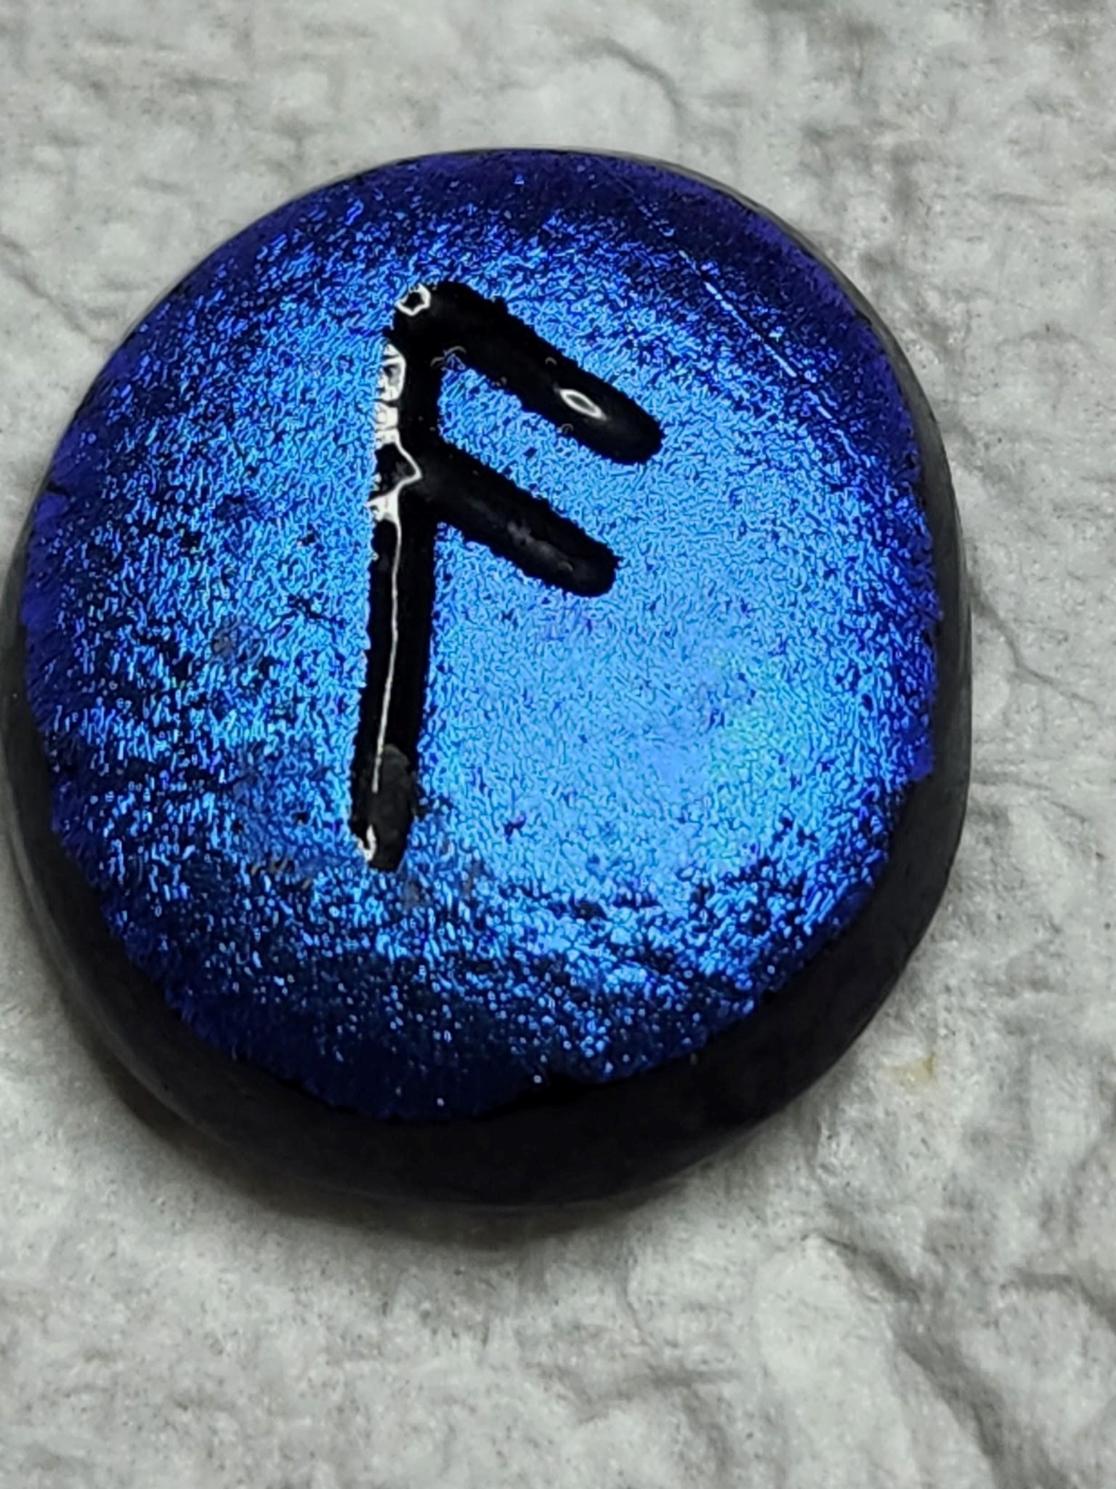 ANSUZ - Signals/Messenger This is an intuition rune. Listen to your inner voice, pay attention to signals, feel confident in your gut feeling and the 'little voice' inside. Looking at the symbol, it's like you're standing but with your antenna down, listening to yourself without outside interference. REVERSED - You're basically not listening. You feel overwhelmed or frustrated, but it's because you're closed off or not seeing/hearing your inner voice.
.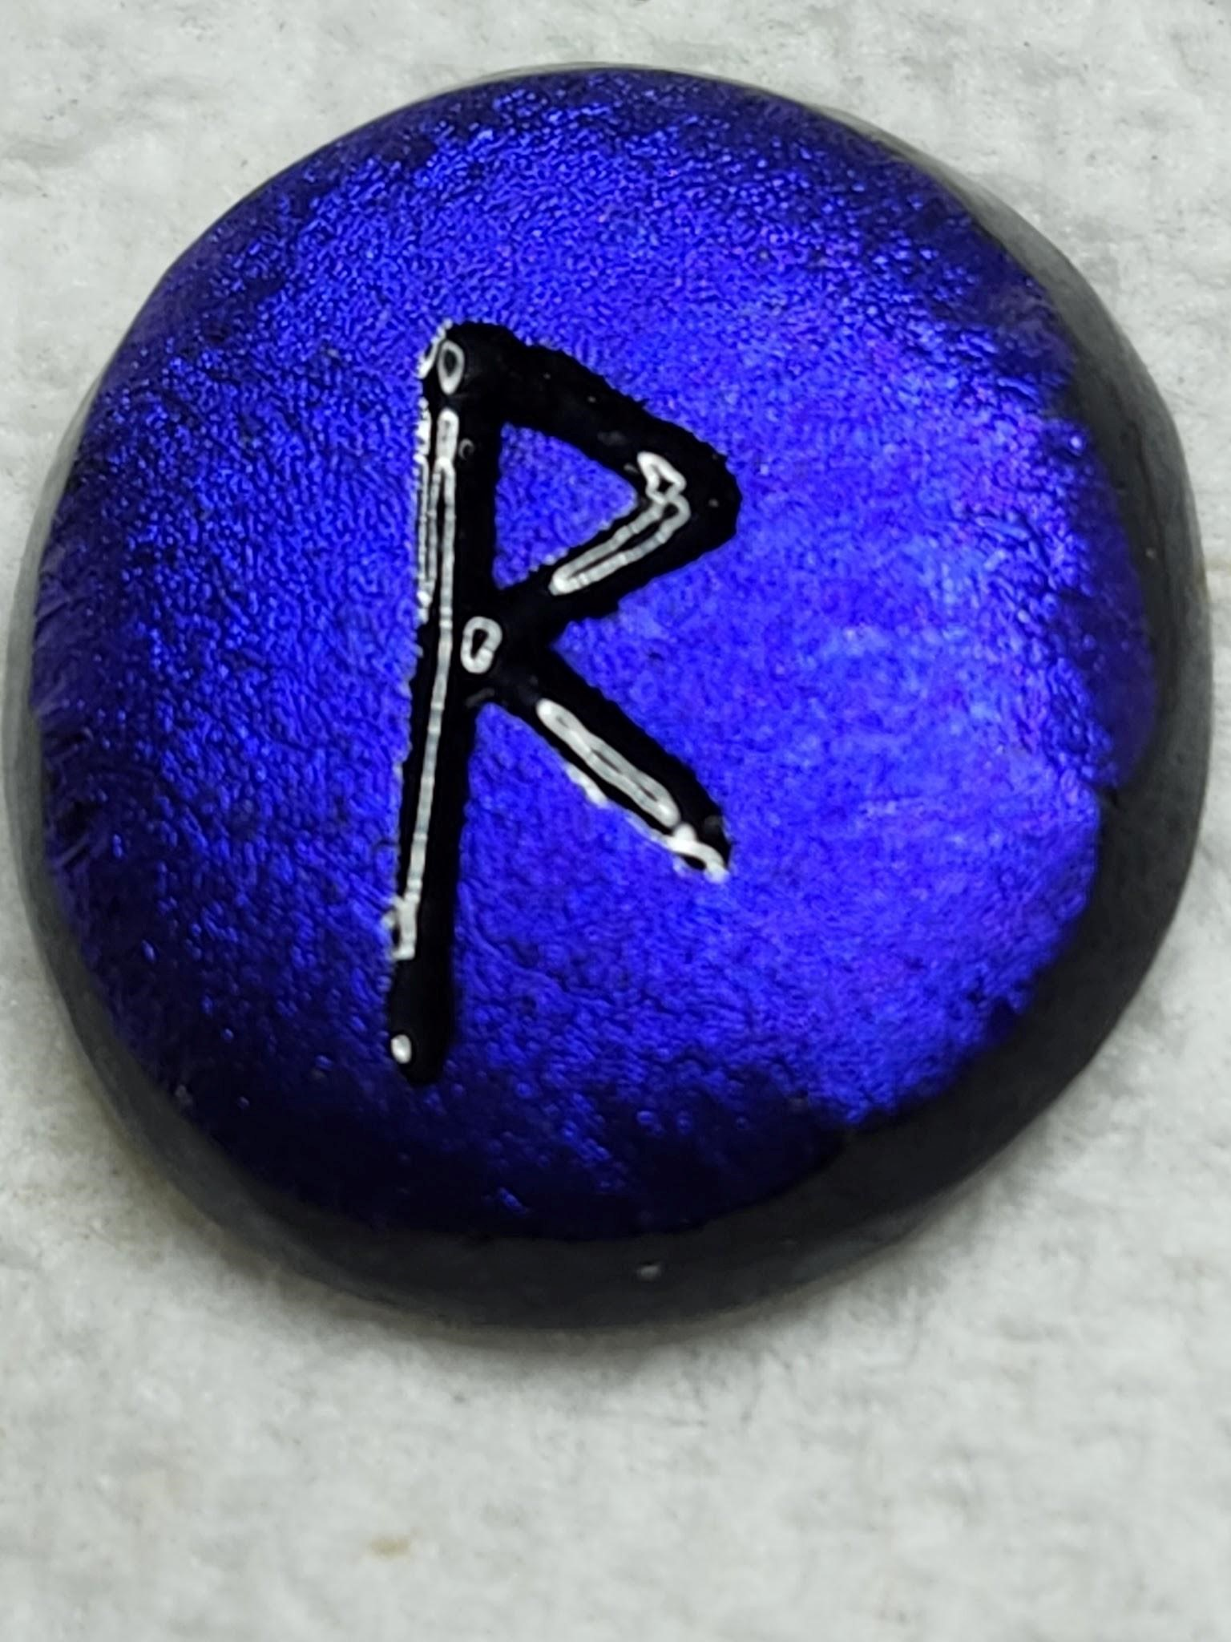 RAIDHO Journey/Communication/Union-Reunion - The journey is towards self-healing whether inner or outer self, also change. You're moving and learning and starting to see a light ahead and leaving behind what you don't need anymore .For any journey you want to lighten your load and get rid of excess baggage. It's also about communication and connecting with yourself, things are starting to make sense and you see you're progressing. It gives you hope and reassurance. Looking at the symbol, it's rather like putting your foot out to take a step, moving ahead. REVERSED- Instead of union and communication, it's ruptures or blockages. And it can be obstacles we create from not hearing, or trying to force things to happen. But it wants you to use these obstacles as a wake up call to realize what you're doing and fix things.
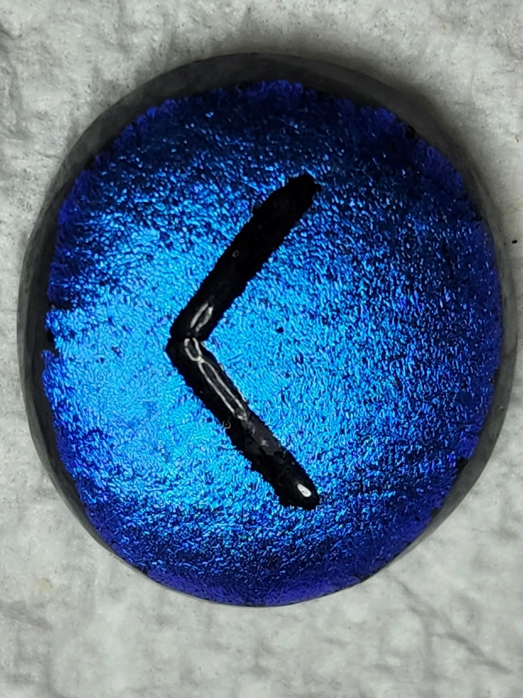 KENAZ- Opening/Torch - The more light you allow in you can see more clearly. You've been working in the dark long enough and you've made it far enough that you can use your experience to start seeing again. If you look at the symbol, with the opening facing right, it can look like the light coming from a flashlight/torch. REVERSED - (Opening facing left) You are lost in the dark and you need to fact up to the fact that you need to change things now and stop wallowing in the "poor me"
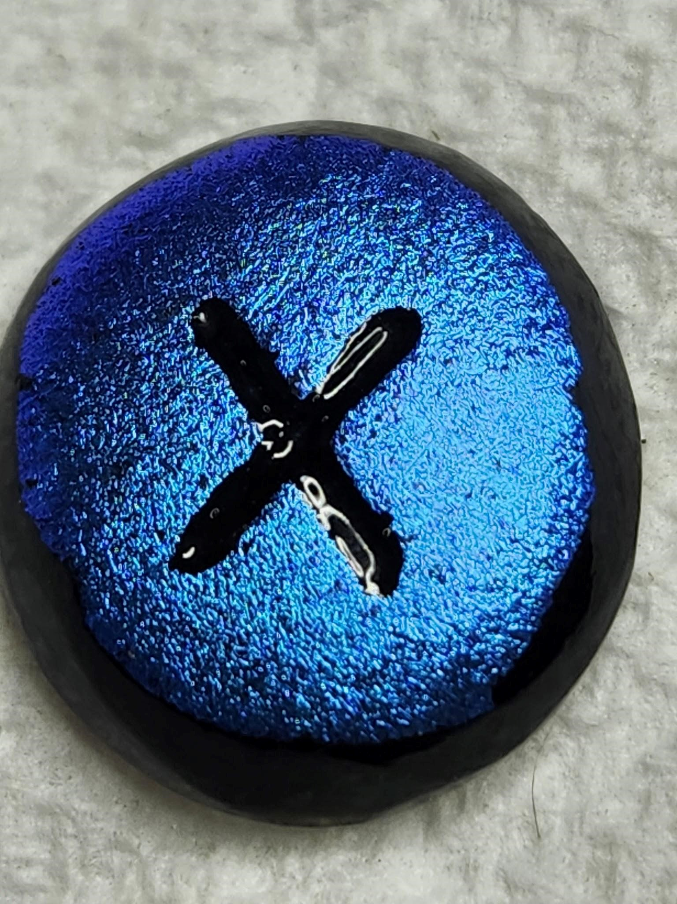 GEBO - Partnership/A Gfit - Partnership in some form is at hand - love, business, partnering of any kind. But you're not to lose yourself in the partnership. It takes 2 separates to make 1 whole. It can also be for you to consider a higher partnership between you and the Higher-Self, realizing the divine in all things. There is no reverse as this rune signifies the give of freedom from with all other gifts flow. It’s a large X, picture yourself standing in this position letting everything flow in and/or out of you.
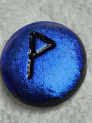WUNJO – JOY/LIGHT/BLISS – It is a fruit-bearing branch. The time of hard work is over and you have shifted and freely receive blessing whether material, emotional or heightened sense of your well-being. New energy and joyousness, that has been blocked until now. There is a new clarity where you may need to get rid of existing plans, ambitions or goals and see peace and contentment within yourself. REVERSED - Things are slow in coming. A crisis or difficult passage may be at hand, however, it will be brief. You'll need to learn patience and perseverance, as you know everything is a test. Focus on the present, being sincere towards others and trusting in yourself. Looking at the symbol, it looks like a large P, so try to think of peace and patience. 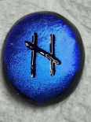 HAGALAZ - Disruption/Destructive Forces - Disruption and events that seem to be totally beyond your control. It's the Great Awakener, however, the awakening could take different forms - a gradual feeling of coming to your senses or a total ripping away of everything you felt,understood or believed in. Whether you created the disruption or was from outside sources, you're not powerless - your inner strength is what is you will rely on now. The more severe the disruption the more your requirements for growth, you are being demanded to be strong and grow. This has no reverse. The symbol is a big H.
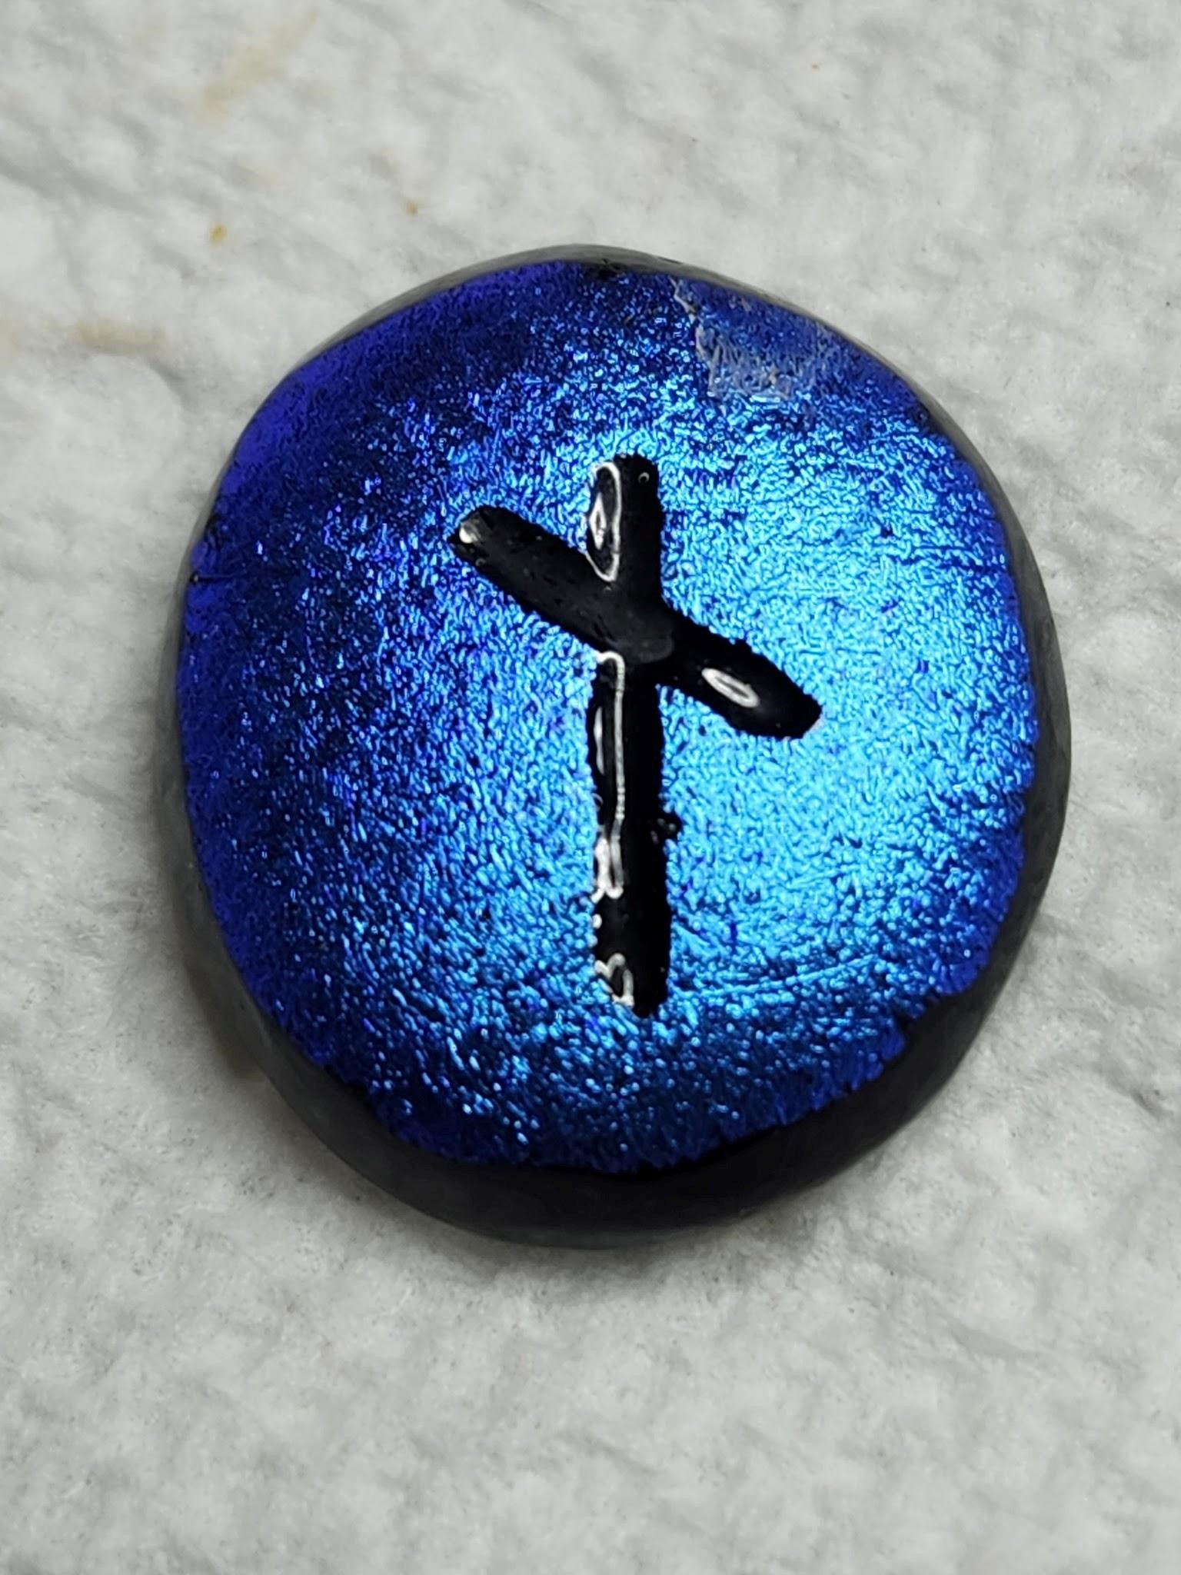 - NAUTHIZ – CONSTRAINT/NEGATIVES - This is to find your dark side or shadow. Find what in your nature that attracts hardship or misfortune. There is a need for restraint as there may be hold ups and reasons to reconsider plans carefully as there is work to be done on yourself. Pay off old debts, restore harmony or balance, mend. Rectification must come before progress and always consider the uses of adversity. REVERSED- Teacher disguised as the bringer of pain and limitation. Only at our moment of greatest darkness do we become aware of the light within. When things are at their worst is when we learn to fight the hardest. A cleansing is required, controlling your anger, restraining your impulses, keeping your faith firm are all at issue here. Modesty and good temper are essential.
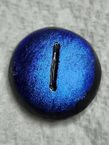 ISA - Standstill/Withdrawal/Ice You're in your winter. Be patient, do nothing, this is a gestation period that precedes a rebirth. Submit and be still, sometimes surrender is courageous. Use this time to cleanse and get rid of all that's holding you back. Recharge your battery and get ready for spring. The symbol is a straight line goes nowhere.
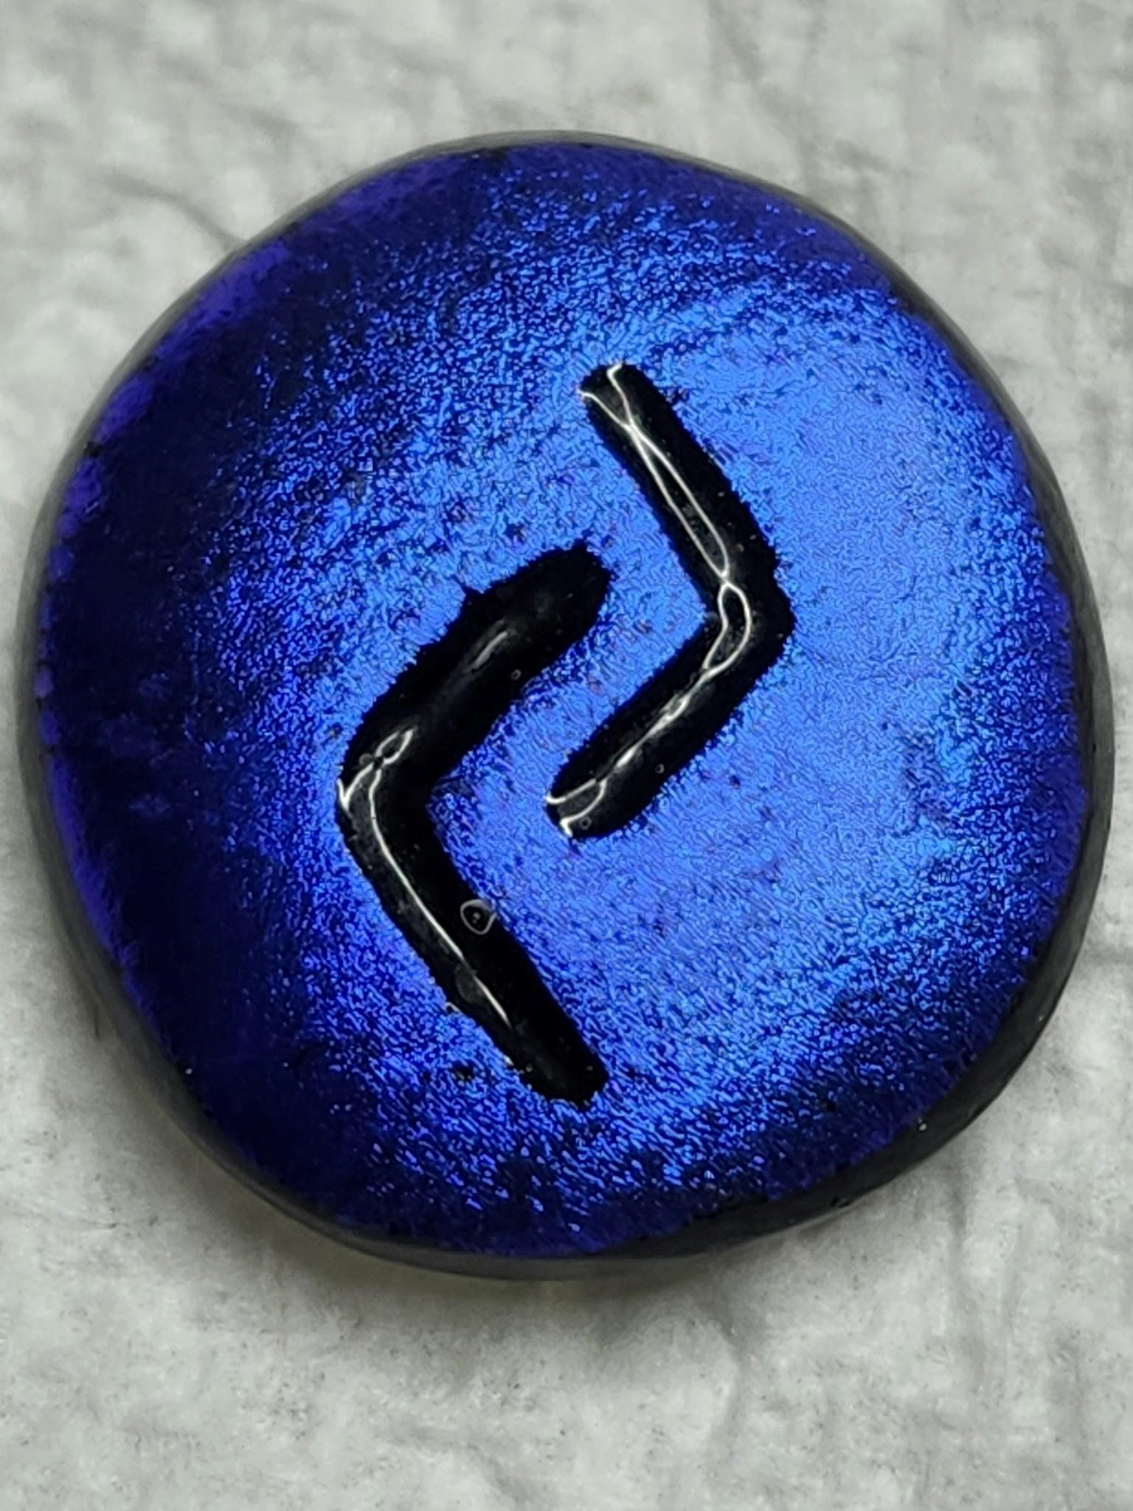 JERA - Harvest/One Year - Beneficial outcomes to whatever you are truly committed. However, no quick results. "One year" stands for a cycle, you plant, you cultivate carefully, you wait, then growth. Know you can't force growth, be patient.The symbol looks like it's going both ways in turn, think of a cycle.
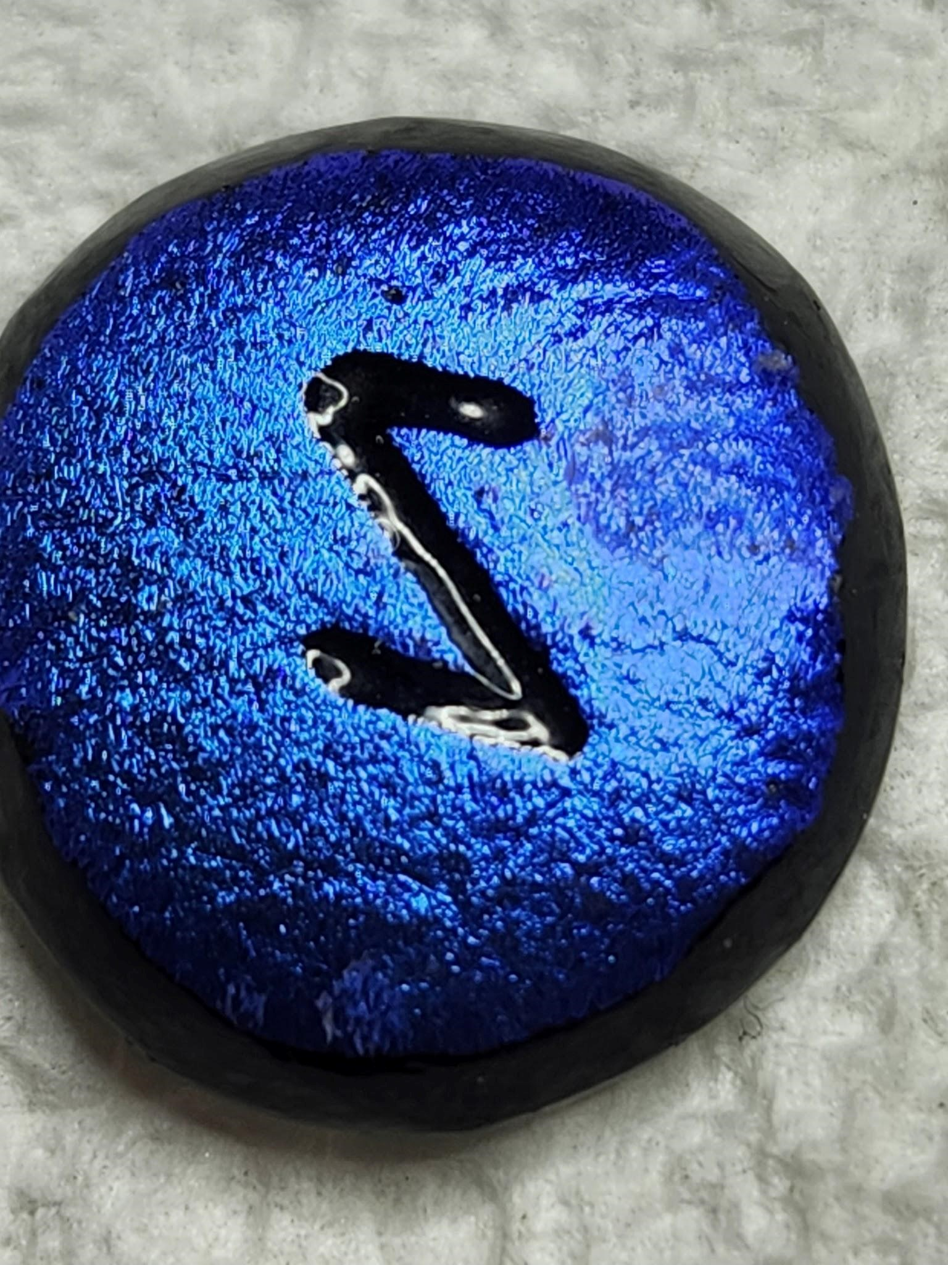 EIHWAZ -Defense/Avertive Powers/Yew Tree - As we are tested we learn to avert blockages and defeat. Patience, perseverance, endurance, foresight. As you've learned from past mistakes and errors, you now know how to work around them and avoid more of the same. This may be a trying time but a meaningful one. So get your house in order tend to business, be clear and wait for the Will of Heaven. No Reverse.
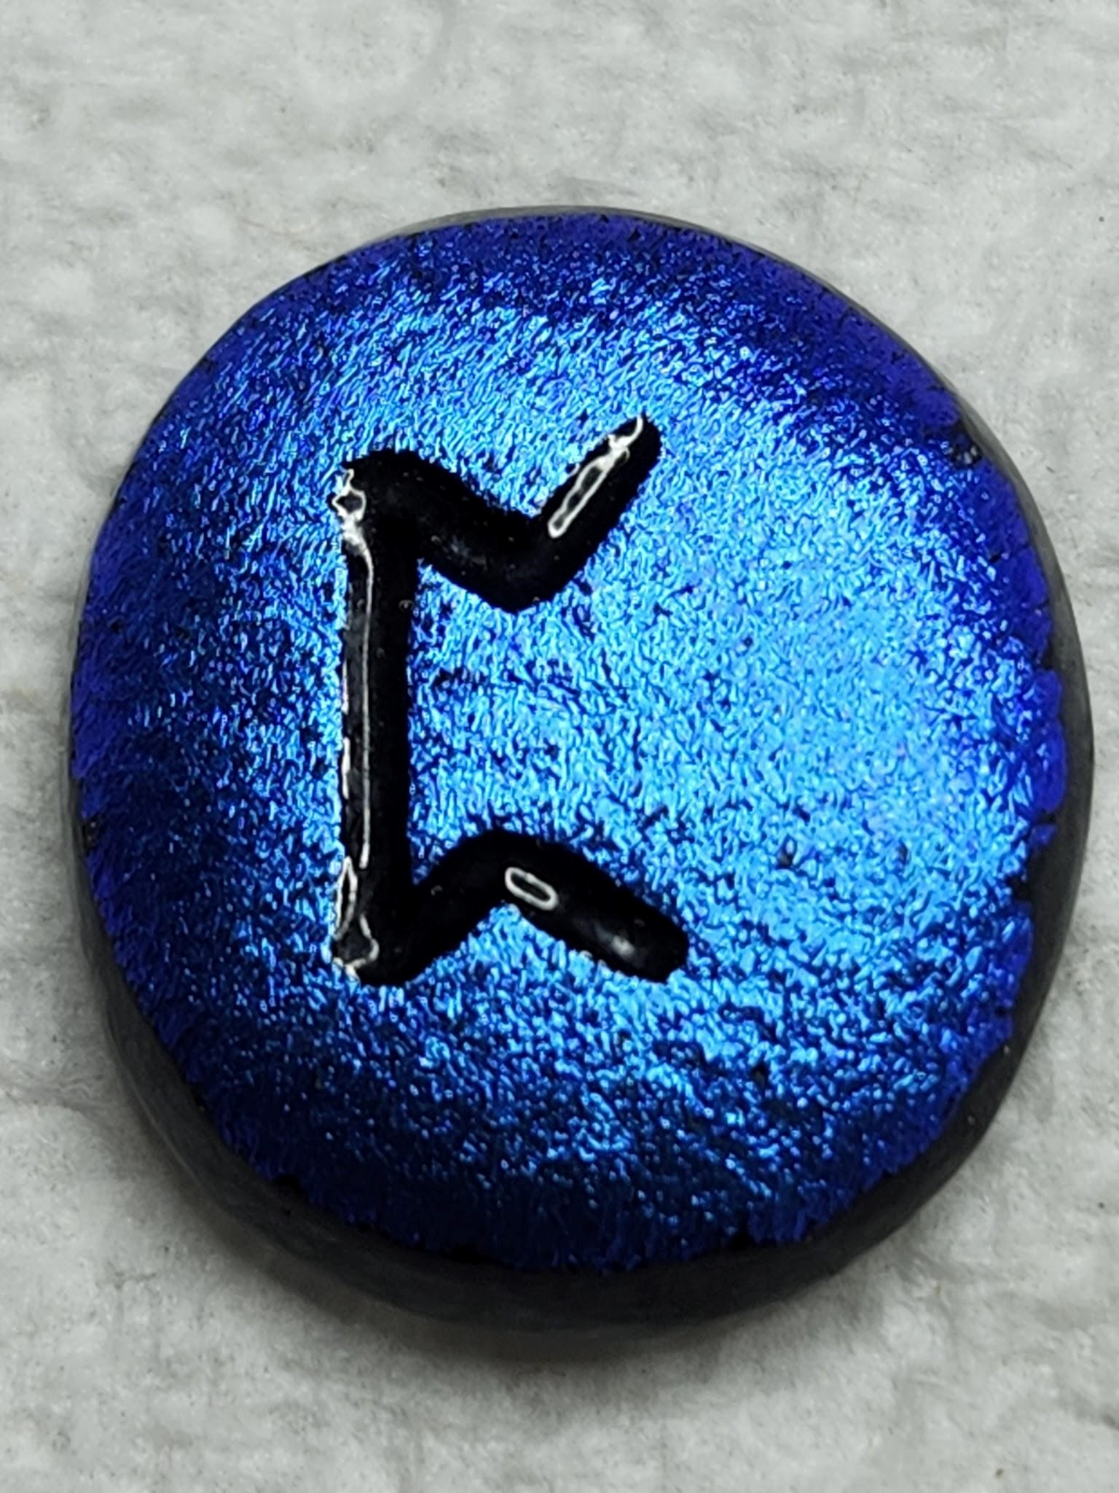PERTHHRO - Initiation/Something Hidden/ Secret Matter - Associated with the Phoenix, consumes itself and rises from the ashes, it's ways are secret and hidden. Powerful forces of change are at work here, though not seen. It symbolizes rising above and flying free, letting go, no exceptions/exclusions, nothing less than total renewal of the spirit. REVERSED - Don't expect too much, as the old way has come to an end, you cannot repeat the old and not suffer. Concentrate on your own life at this moment, forget the past and don't focus on outcomes. Just stay centered, constant, patient and see the humor and keep your faith firm and ride it out as best you can.
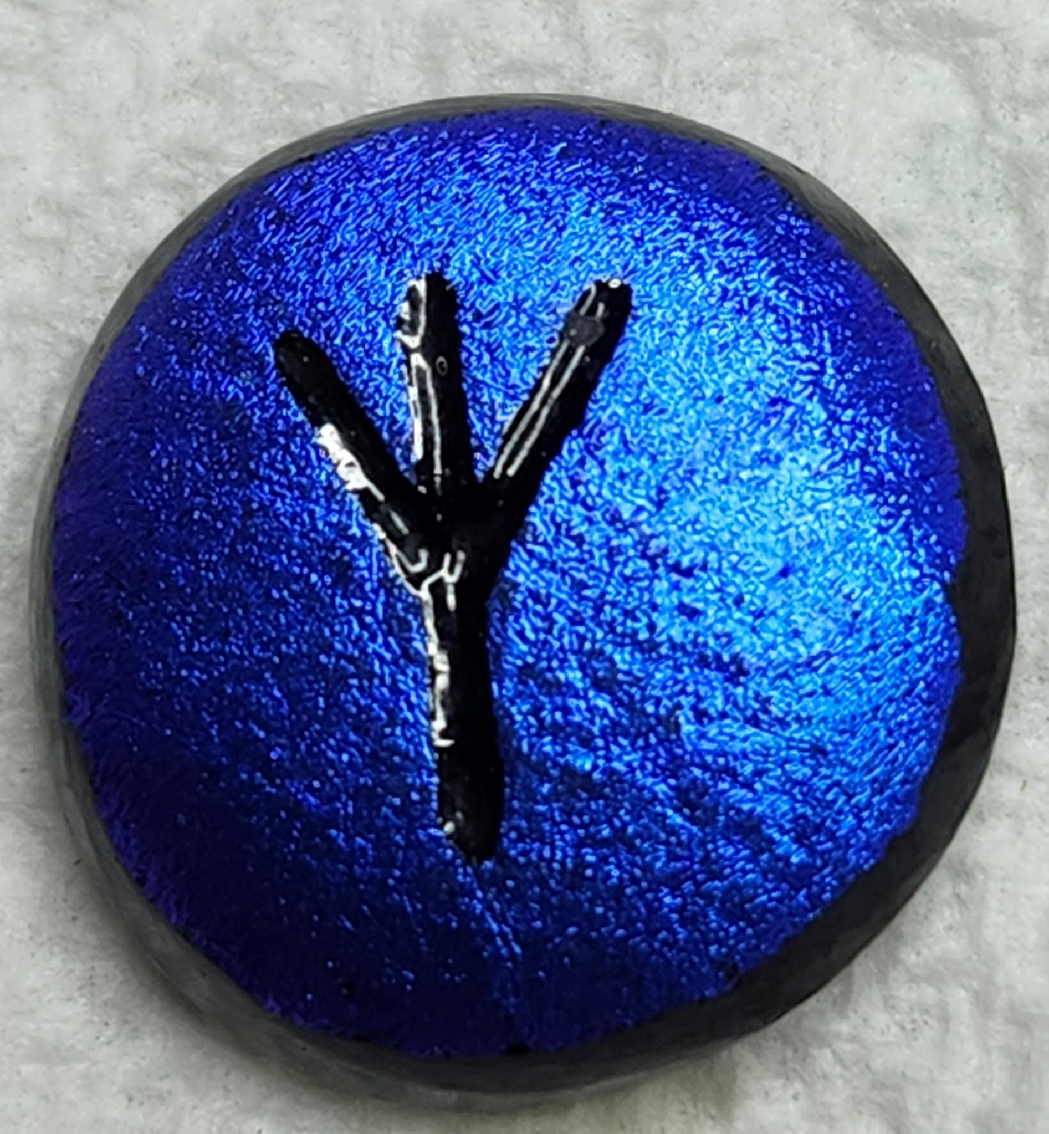. ALGIZ - Protection/The Elk- Control of emotions is called for. Do not fall into your emotions. If you feel pain, observe it and stay with it, don't pull away and hide from it or try to escape. You are protected with space around you to leave you open yet protected. New opportunities and challenges are typical with this rune and with them come trespass and unwanted influences. Be aware you're protected and keep yourself on track. -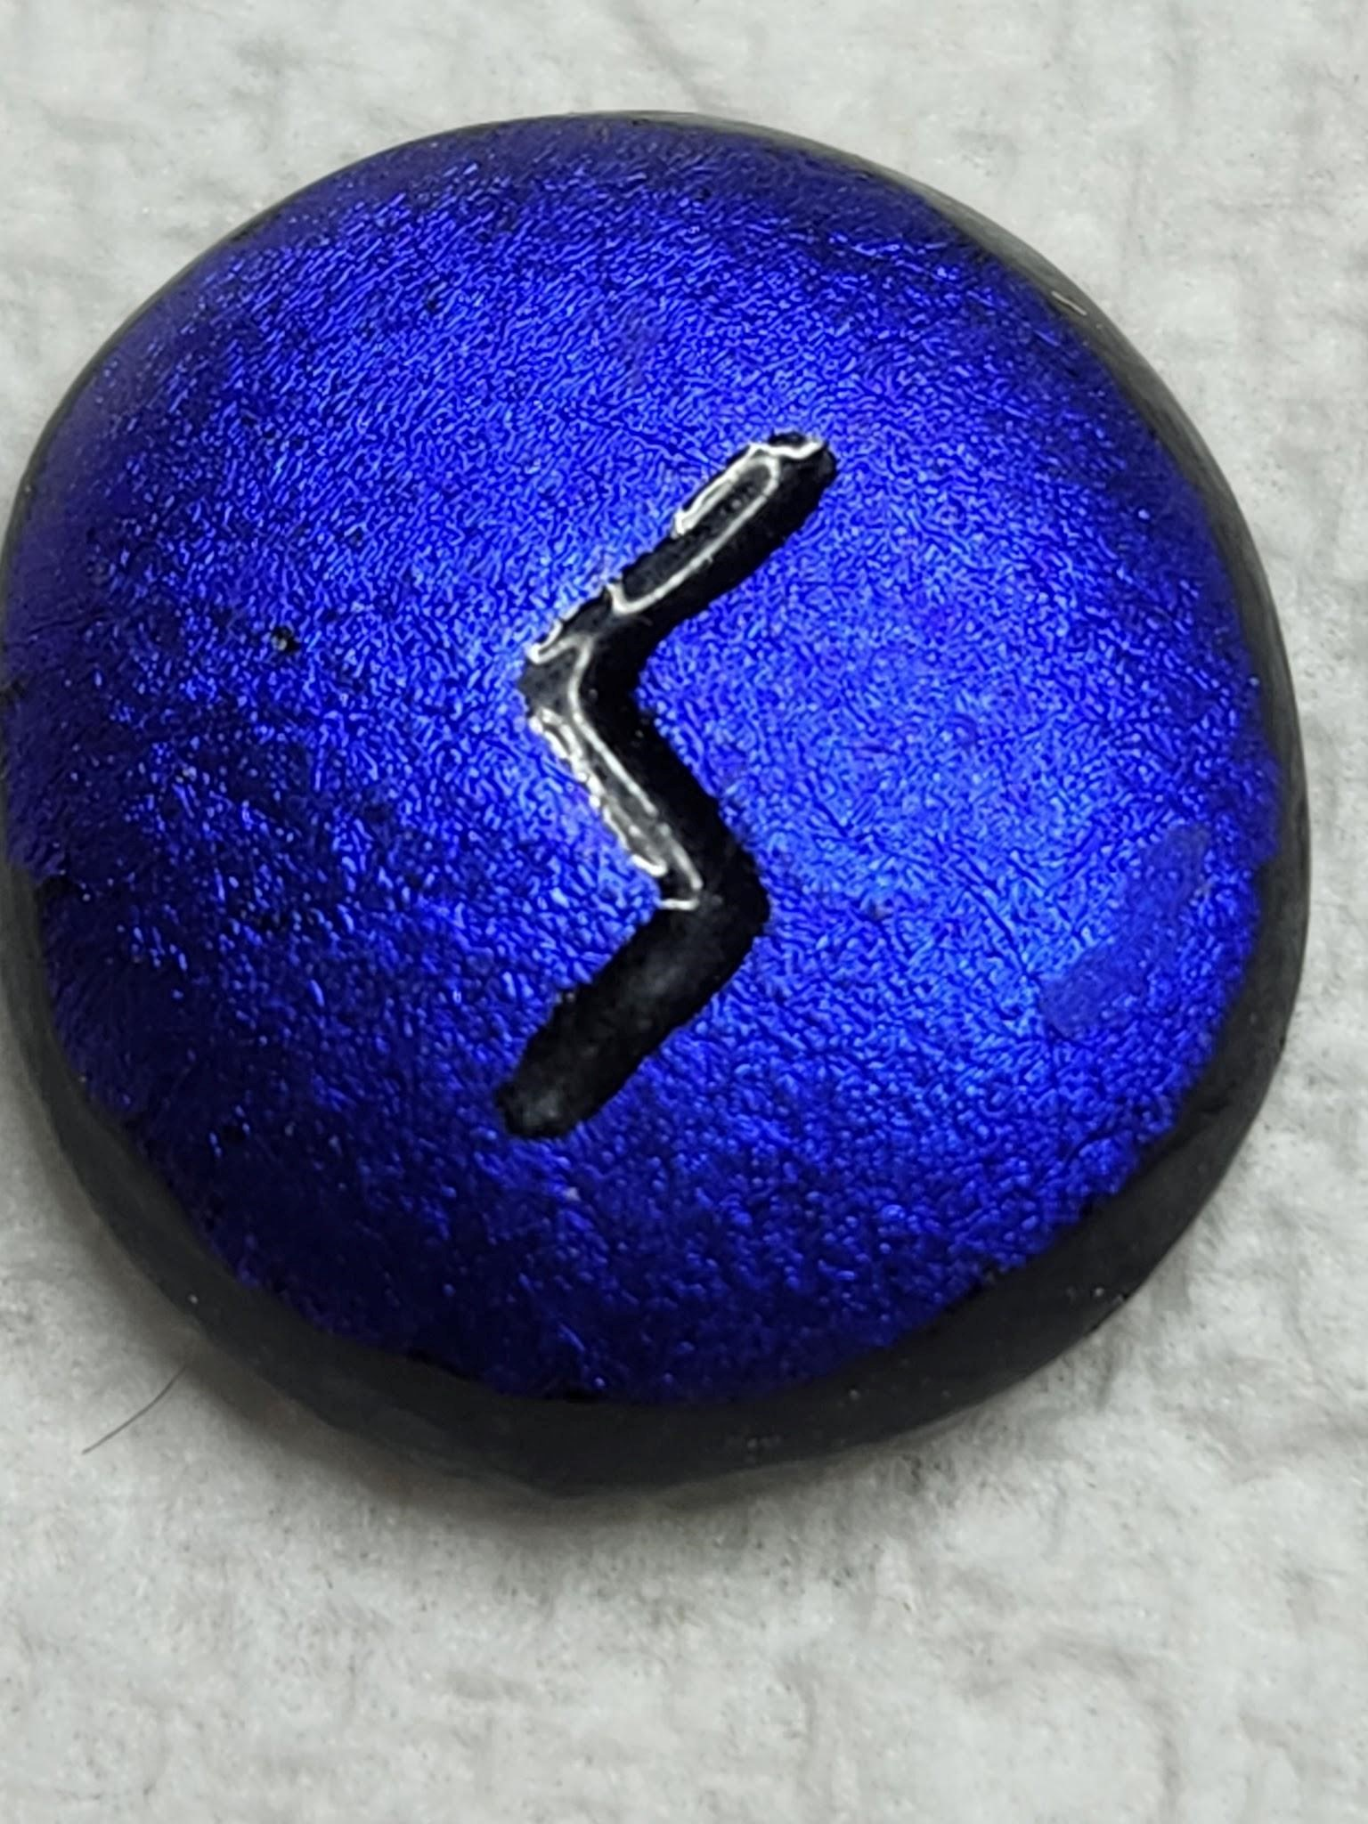 SOWILO – The Sun/Life Force - What you are striving to become is what you actually are, you just don’t realize it. You have to become aware of your true inner core, it's a time for regeneration. There is also reason for caution. You may feel a need to retreat or withdraw in the face of some pressing situation. It may be best to be careful and withdraw if you feel you're being overwhelmed by demands, consider it a chance to center or balance yourself. Knowing when to back off is a skill. For wholeness you need to open yourself up and maybe have to face things that you have long denied or refused to admit to yourself The symbol pretty much looks like a big S, so try to think of Sun (letting the light into your true self).
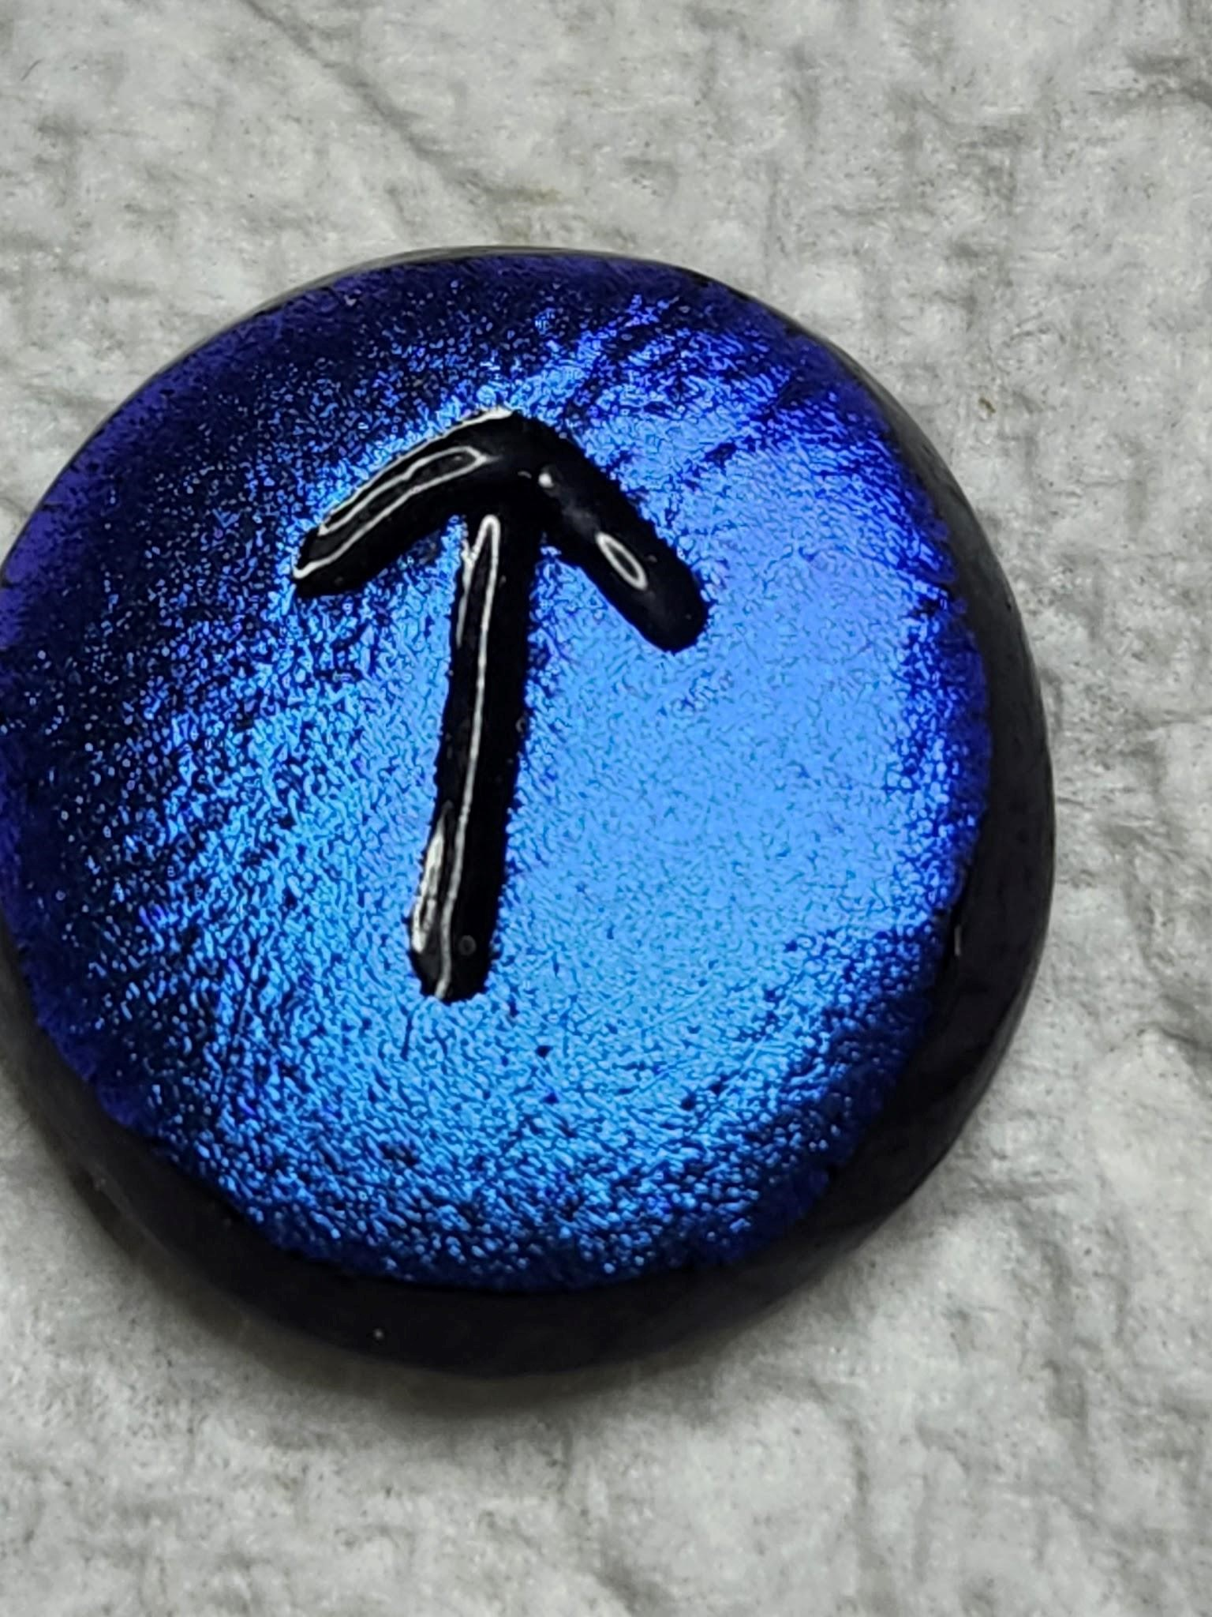TEIWAZ - The Warrior/Sky God- This is the rune of the Spiritual Warrior. The battle is always with the Self. You have the strength to cut away the old and dead wood, however, you also know when to let the universe do what it needs to do. The reward of patience is patience. There is masculine energy and urge for conquest is powerful with this rune .When it comes in response to a relationship issue shows the relationship to be timely and providential. When it comes to devotion to a cause, path or idea, it calls for perseverance and yet patience. Be aware you're protected and keep yourself on track. REVERSED – Danger through hasty or ill-timed action. Matters of trust and confidence are at issue and you question your place in the world. You need to examine your motives closely. Are you doing what you think is right or trying to force or overcome another. Are you lusting for outcomes or focused on the task for its’s own sake? The answers are inside. NOT in outside advice

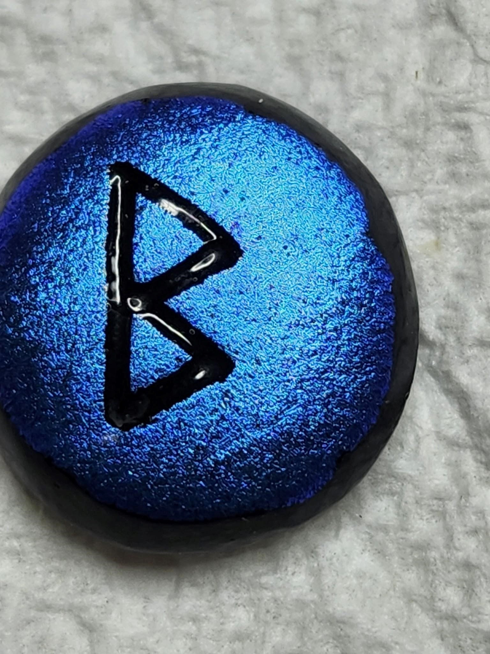. BERKANA Growth/Rebirth - Another of the “cycle" runes. Berkana represents a form of fertility forming growth both symbolically and actually, could be world/family/relationship/self matters. There is concern for the flow into your new forms. Consider the issue with care, get rid of resistance and then just do it. Modesty, patience, fairness and generosity are called or....no motives that are not true, no dark corners, clean everything out, and blossoming can occur. REVERSED- Events, but more likely parts of your character are interfering with your growth. You may be feeling bad that you made a wrong choice or bad decision, examine your role, your needs, others’ needs, are your wants being placed before your needs or that of others? You'll get through the rubble and find the right decision for the right reasons. Looking at the stone, it looks like a pregnant profile so think of Rebirth!
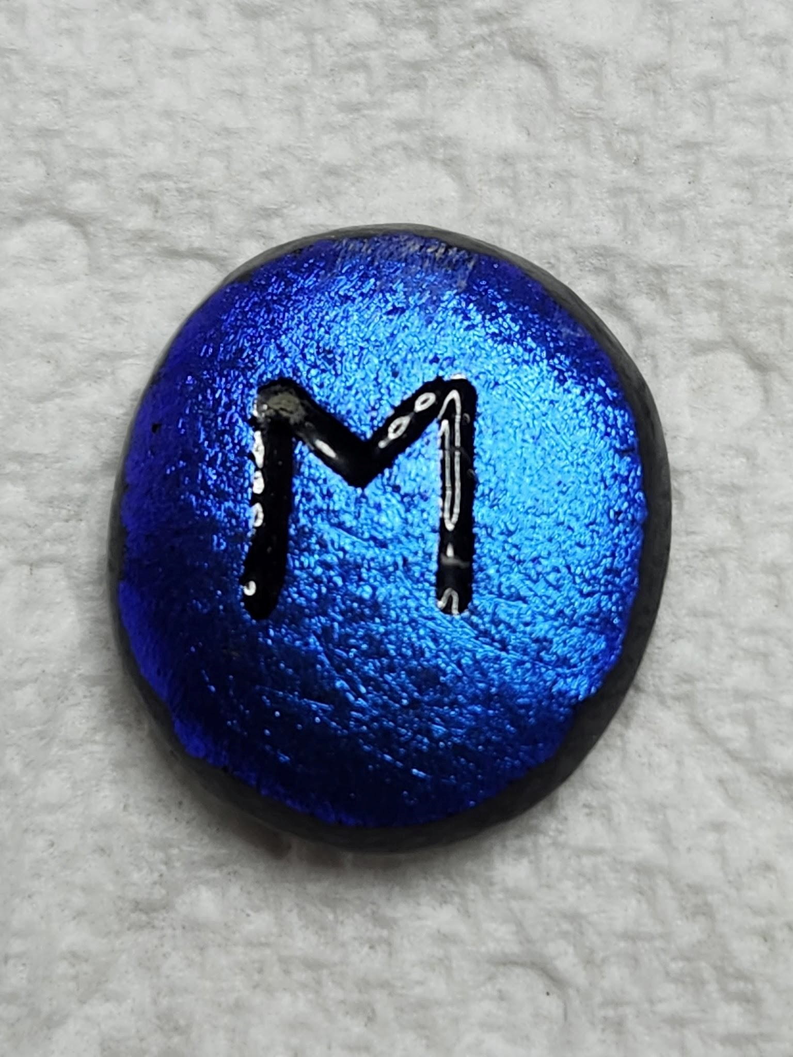 EHWAZ - The Horse/Movement/Progress - A rune of transition and movement - physical shifts, new dwelling places, new attitudes or new life, also movement in the sense of improving or bettering any situation. There is a sense of gradual development and steady progress, slow growth through shifts and changes. You've progressed far enough to feel some safety in your position, but time to turn again and face the future with confidence. REVERSED- If you’re feeling blocked start by being truthful and clear, with yourself. Don’t look around you at what you think is causing your problems. but look into yourself and recognize what you are responsible for and what you’ve not been admitting to yourself. Breaking the momentum of past habits is the challenge here.The symbol looks like a large M, so think movement

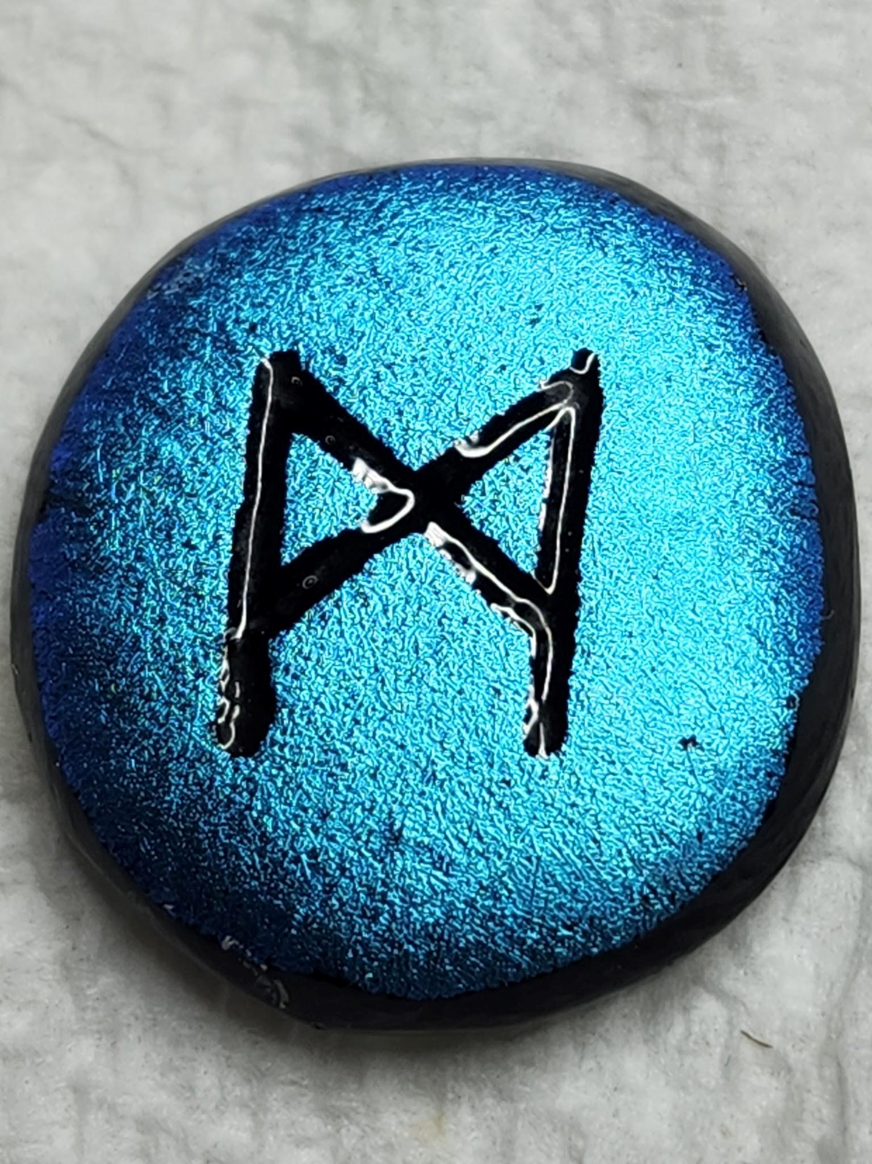 MANNAZ -: The Self – The starting point is the self, “KNOW THYSELF” . You need to form a relationship with yourself. Get to know you and who you really are, and from this things will flow. Don’t let your ego get the best of you, remain modest. Do not be closed, narrow or judging, remain open to your instincts flowing from you and from the universe. Be aware of what comes and goes at all times and focus on what stays. This is a major time of growth The field is tilled before the seed is planted. This is not a time for seeking credit for your accomplishments, but rather to do what you need to do and be content to be in the present. There is subtle caution against carelessness. REVERSED – If you’re feeling blocked start by being truthful and clear with yourself. Don’t look around your at what you think is causing your problems, but look into yourself and recognize what you are responsible for and what you’ve not been admitting to yourself. Breaking the momentum of past habits is the challenge here.

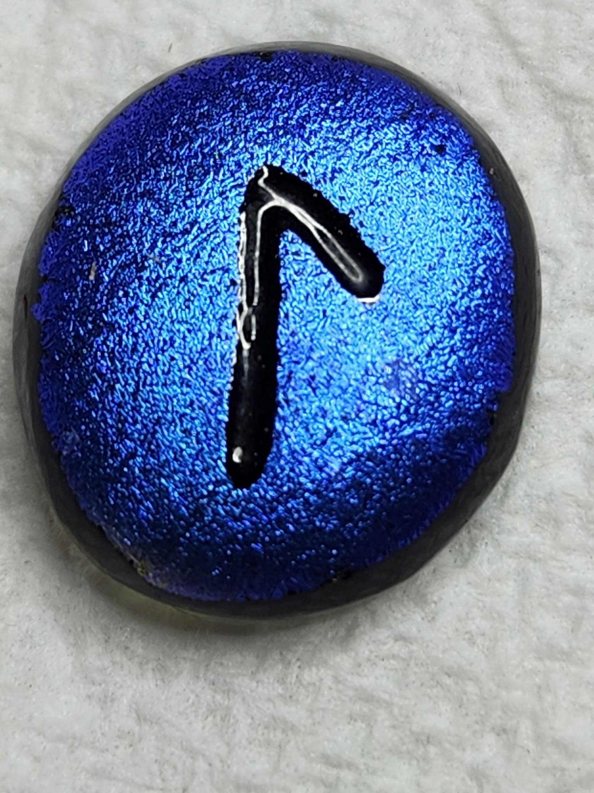 LAGUZ - Flow/Water - Unseen powers are at work; powers that nourish, shape and connect affecting the flow of emotions, careers and relationships. Immerse yourself in living without having to analyze or understand everything, just be. This rune signals a time for cleansing, revaluing, reorganizing. You need to contact your intuitive wisdom and attune to your own rhythms, a time for self transformation. REVERSED – Movement that appears to block. Be assured that what you are or are not doing, is correct. There are no missed opportunities, just realize not all opportunities are appropriate. The correct action at this time may be to avoid action. If your’re unclear at this time, remember, “what is yours will come to you”. Be patient and let things flow.

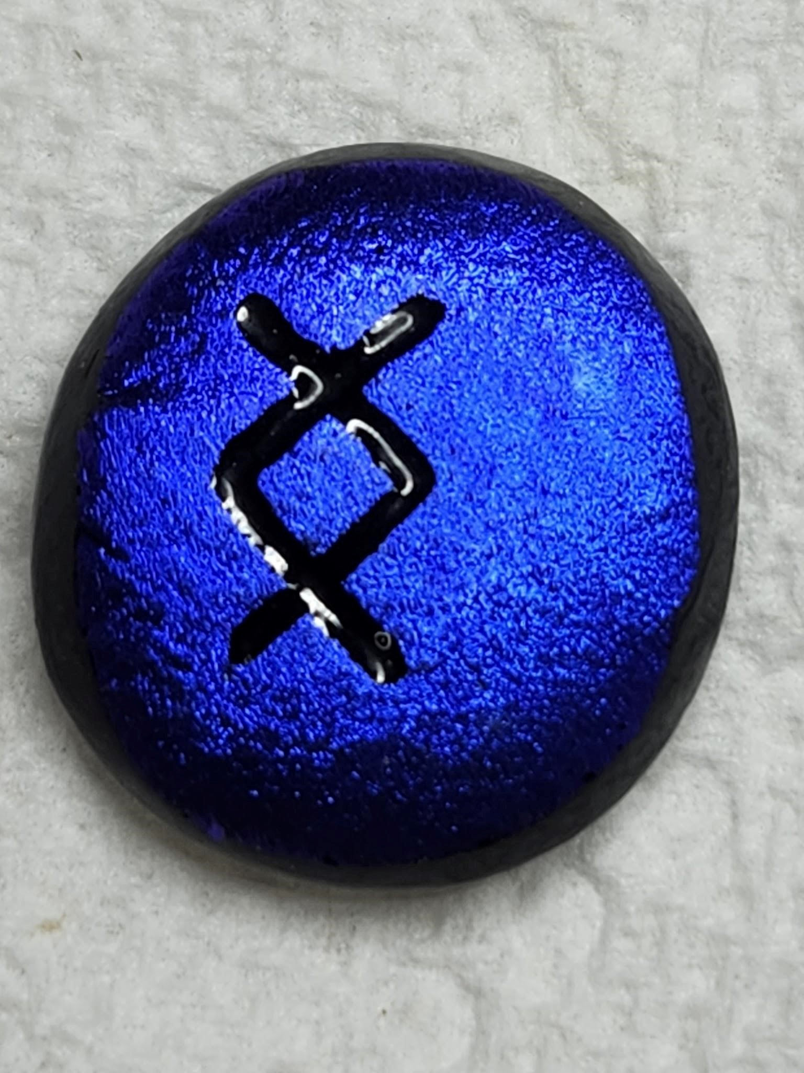 INGWAZ - Fertility/New Beginnings . This is the intuitive part of your nature urging you toward harmonizing and adjusting personal relationships. You have the need to share, to be desired and to search for similarities. This is the completion of beginnings. It’s a new life, a new path, you now have the strength to achieve completion, resolution, a new beginning. Completion is important, you are emerging from a closed state and you need to clear away the old and useless and experience a release from tension and uncertainty. Free yourself from ruts or old habits or relationships. Movement can involve danger, but if it’s timely, it’s moving out of danger. Be centered and grounded, freeing yourself from all unwanted influences and seeing the humor, you are prepared to open to the Will of Heaven and await your deliverance with calm certainly. Looking at the symbol see growth as they are climbing upward.

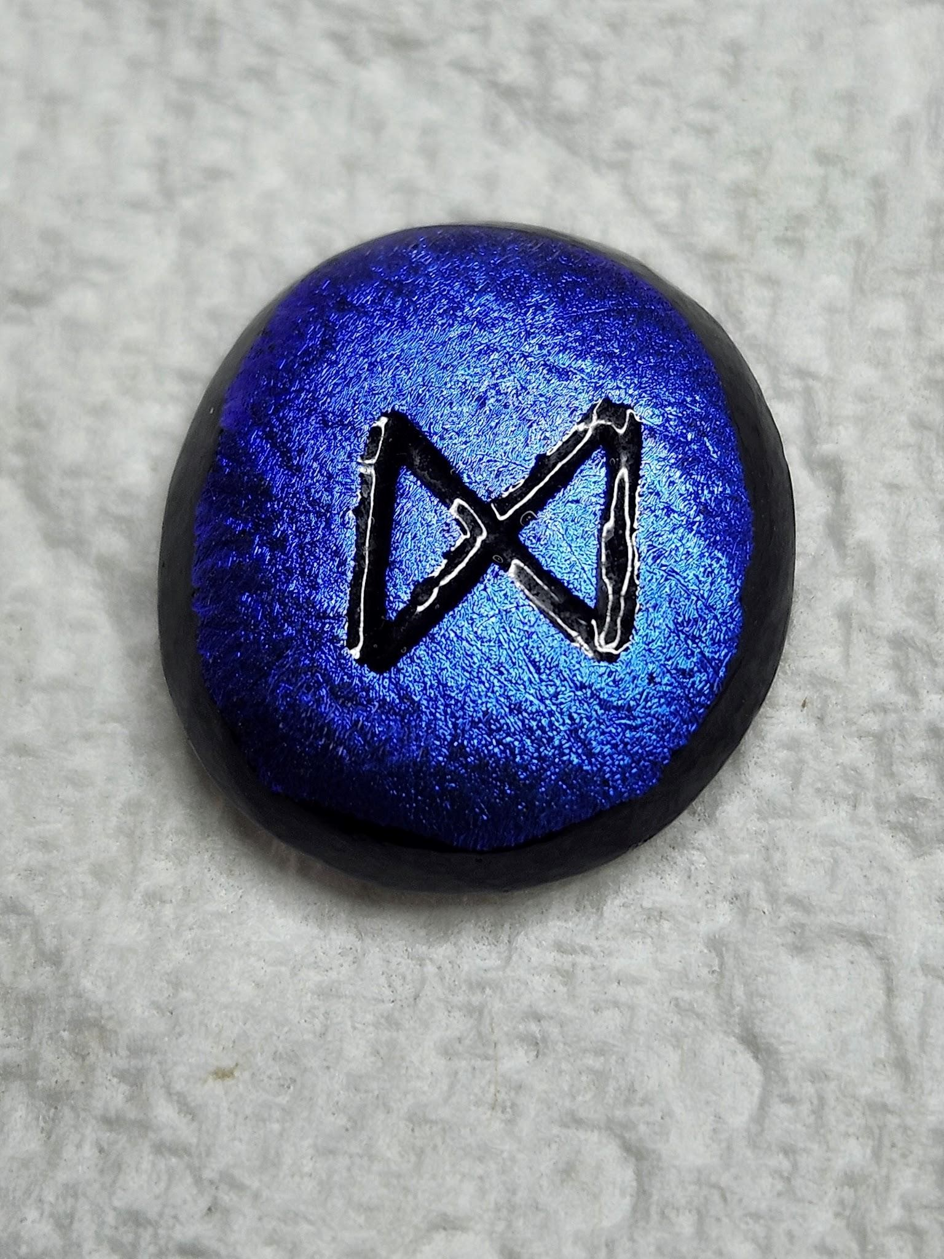 DAGAZ – Breakthrough/Transformation – This rune often signals a major shift or breakthrough in the process of self-change. It could be such a drastic change you are no longer able to live your ordinary life as you have until now. In each life there comes at least one moment that, if recognized, changes the course of your life. However, you may have to make a “leap of faith” as you will be called to listen to your gut instincts and believe in yourself. Usually a major period of achievement and prosperity as the darkness is behind you and you’ve come into the light. Just don’t be reckless and feel that all is done and you have no more work to do, as you must continue to work on self, but do it joyfully. Looking at the symbol, think of balance as each side is equal.

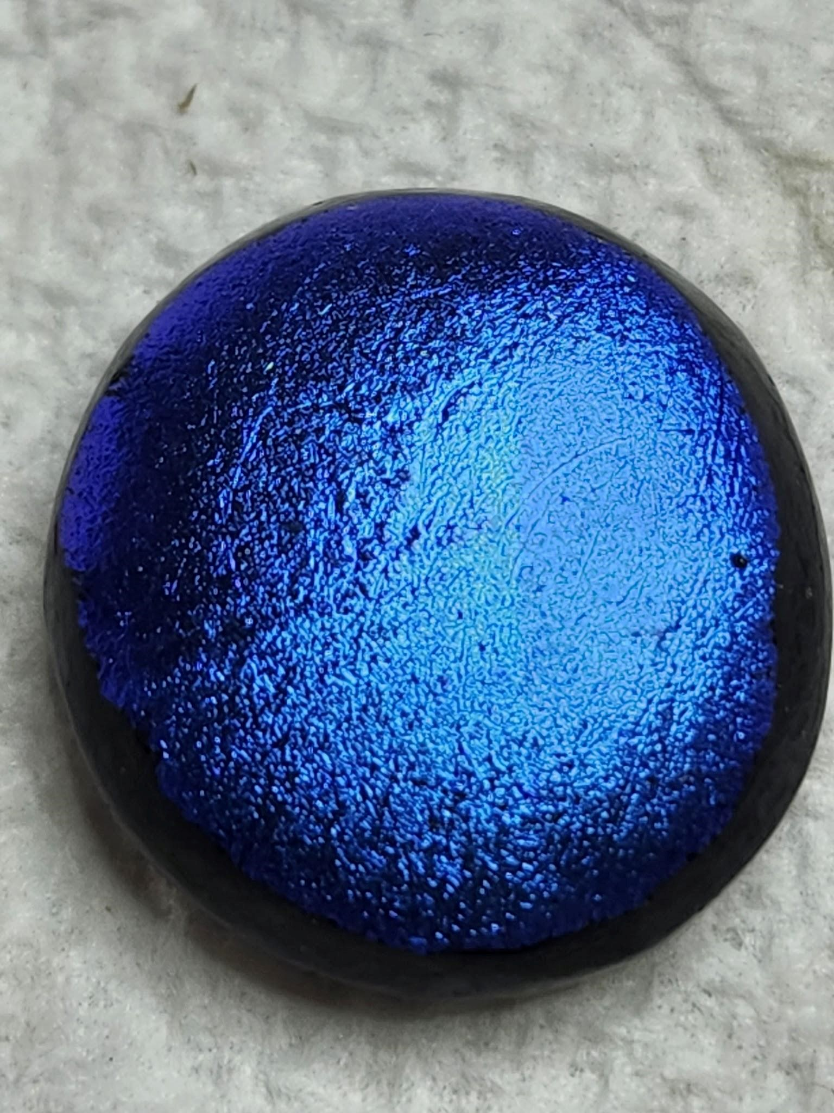 BLANK RUNE – Unknowable/The Divine - Anything is possible and can happen. The sum total of who you are, what you have done, and what you have become. Choose a direction and go for it. Consider it a blank page for you to start writing your life on and only you can do that and you are at a time when the future is yours to make, make of it what you will. Face your fears and admit them and have the courage to change them. Nothing is predestined, you are in control of you.

